If you would like to learn more about RLI, visit their webpage at www.RLIHOA.org or contact one of the following individuals:

Data about your District, along with contact information
can be entered here.

Multiple Districts can share
this brochure at jointly held events.

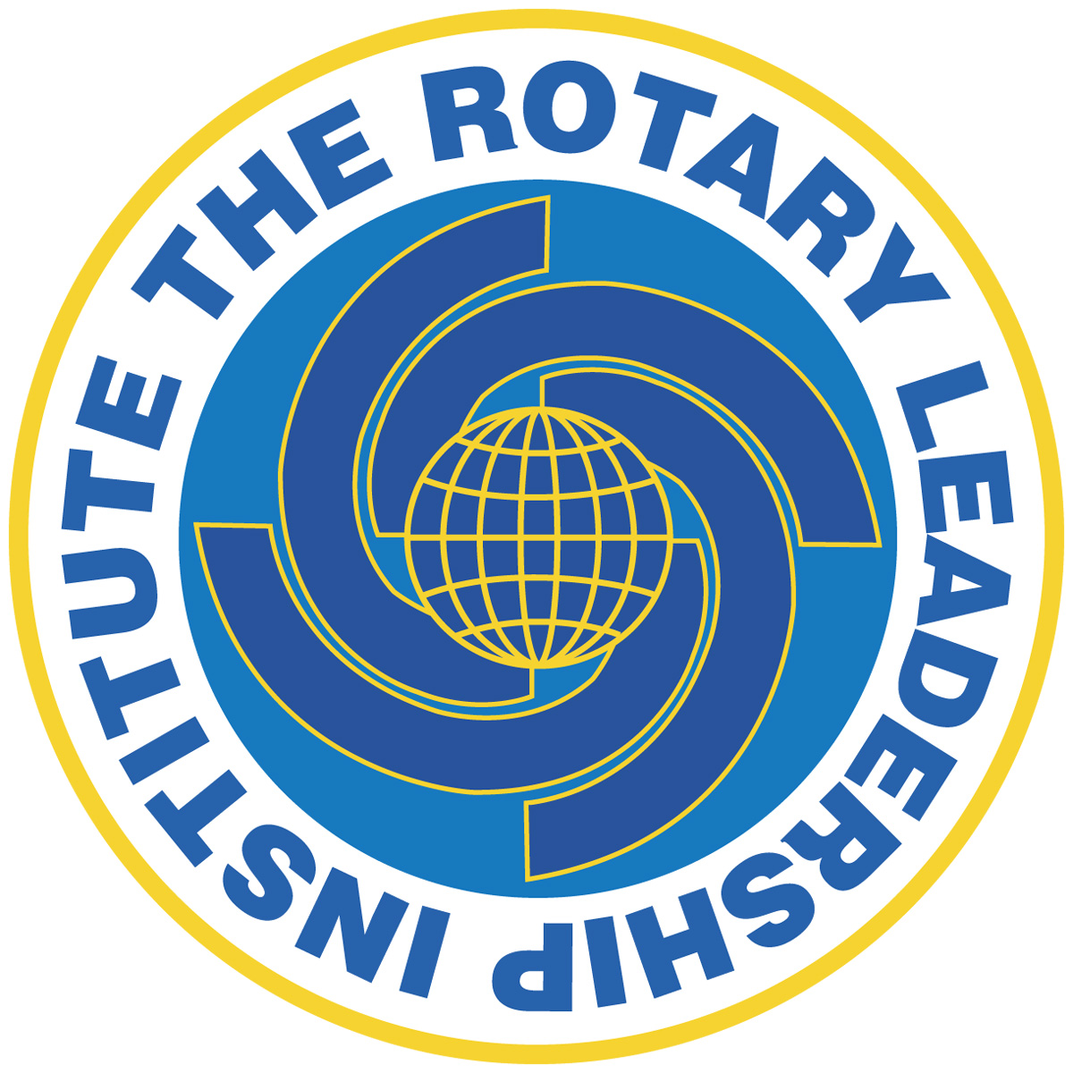
What are people saying about RLI Courses?
“I found the day very informative
and fun.”
“The program was very well planned and presentations (leaders) were excellent.”
“A very effective seminar.”
“Enjoyed the focus on the chosen issues-great interaction.”
“I have learned quite a bit about leadership qualities and “nuts and bolts” of Rotary.”
“I definitely learned a lot from today’s leadership training that will be beneficial to my club-instructors were all great.”
“I found the preparation applicable to my work in a not-for-profit. Well done!”

RLI is a recommended program, but not an
official program, of Rotary International.

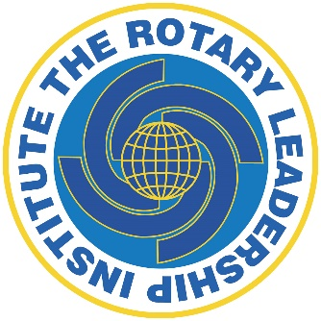

Rotary Leadership
Institute (RLI)

Frequently Asked Questions

Heart of America Division,
Serving RI Zones: 30 and 31

www.rlihoa.org

Frequently Asked Questions:
Why do we need RLI?
It is generally agreed throughout Rotary world that the success or failure of a Rotary Club depends on the quality of club leadership and engagement of members. It has been said that poor club leadership is the primary cause of membership losses. Because of the annual turnover of club officers, Rotary needs a constant influx of knowledgeable Rotarians who have the leadership skills necessary to move a club forward. It is difficult to learn enough about the exciting world of Rotary.

Is RLI important when I have
leadership skills already?
Attendees in the past that consider themselves leaders have been complimentary about the benefits of RLI. Furthermore, leadership skills in a voluntary organization are often different from business leadership skills. RLI provides an opportunity for quality Rotary education that is usually not otherwise available.

What is the philosophy of RLI?
RLI believes that having leadership skills does not alone assure good Rotary leadership. An effective Rotary leader must ALSO have Rotary knowledge, perspective about where Rotary has been, where it is going, and a vision of what Rotary can be.

What are the teaching methods?
The institute believes in course sessions being conducted with as much discussion and participation as possible. Lectures are strictly limited. Course methods include discussion groups, role-playing, problem solving sessions, and creating projects. Everyone has an opportunity to participate. Course materials include session outlines, the daily program, faculty materials, and resource materials to be provided to all participants.

What is the recommended curriculum?
RLI provides a recommended curriculum annually for a basic course in three full days: Parts I, II, and III. These three parts are generally taken over some time, fitting the Rotarians’ schedule. The time between sessions allows the participants to gain perspective through observing and participating in their club’s activities. The curriculum has been continually reviewed and improved as a result of the experience and evaluations of the attendees.

Who are the faculty?
Faculty members are carefully selected for their teaching and facilitation abilities. Each new faculty member must attend a training program and periodic reorientation programs. The training focuses on participation encouragement and effective facilitation, not the traditional and more boring lecture mode. The results of course evaluations help to improve the course content and instruction.

Who should attend RLI courses?
Although any Rotarian may attend RLI courses, it is recommended that Rotary Clubs encourage attendance by Rotarians who have the potential for future club leadership. The ideal candidate is early in their Rotary career, has a strong interest, and is prepared to be exposed to the larger world of Rotary outside of the club. Clubs are encouraged to pay the fees for their members attending the courses.

Should your club participate?
If your club members care about your club’s future, you will want the best leadership possible This is an outstanding opportunity for each club to improve the Rotary knowledge of its key people, who will also be exposed to new ideas of leadership and activities. The exchange of ideas with other experienced Rotarians, that are in attendance, alone makes the courses worthwhile.

What is an RLI Division?
For administrative purposes, RLI creates “divisions” that may consist of one or more Rotary districts, zones, etc. The Rotary Clubs and Districts in RI Zones 30 and 31 are all within the Rotary Leadership Institute - Heart of America Division. RLI has divisions/districts on every Continent of the world except Antarctica.

What are the costs and
where are the classes held?
The in-person courses are normally held in meeting venues around each member District that are conveniently located for attendees. Districts may also opt to conduct on-line courses. The course fees are set by each Division Executive Committee and the District Coordinator, based on site costs, meals, materials, and other necessary expenses. Within the Division the curriculum is the same at any course site so participants may take the various Parts at different sites and dates. In many clubs, the registration cost of attending RLI is covered by the club.

Will RLI contribute to my life
outside of Rotary?
Attendees report that the development of leadership skills in an organization comprised of volunteers has strengthened their ability to lead in non-Rotarian settings. The leadership skills learned are transferrable to all not-for-profit environments, many academic environments, and into businesses with modern-day employee participative themes of management.

